Project Design Phase-II
Technology Stack (Architecture & Stack)
Date | 25 September 2026
Team ID
Project Name | Metro Ticket Generating System in ServiceNow
Maximum Marks | 4 Marks

Technical Architecture:
The deliverable includes the architectural diagram below and the information as per Table-1 and Table-2. The solution is built on the ServiceNow Now Platform: commuters book tickets in the Service Portal, Flow Designer automates booking, simulated payment, QR generation and notification, and the Gate Validation page (backed by a Scripted REST API) validates tickets at entry and exit.
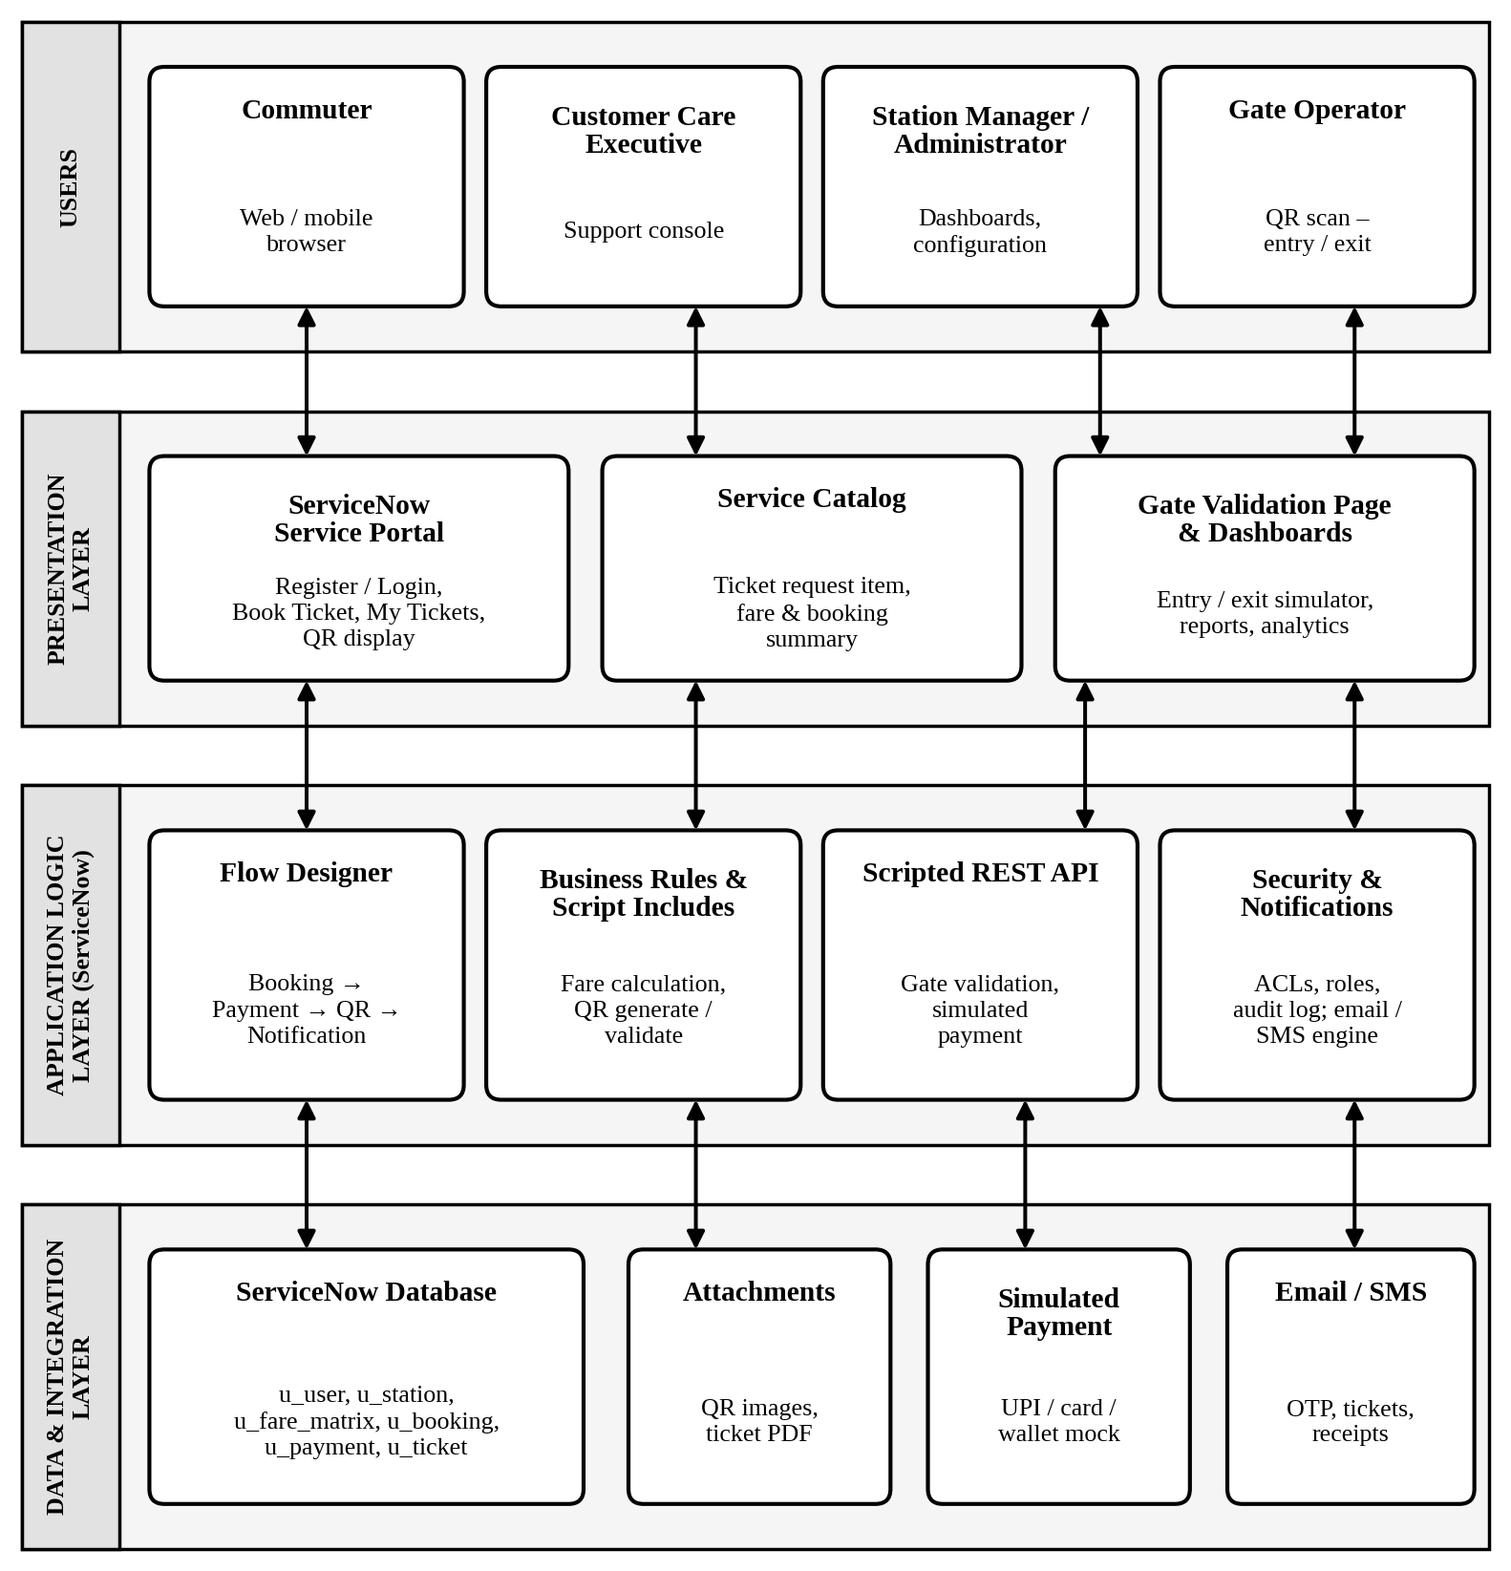
Figure 1: Technical architecture – Metro Ticket Generating System in ServiceNow
Table-1 : Components & Technologies:
S.No | Component | Description | Technology
1. | User Interface | Web / mobile-browser interface through which commuters register, select stations, pay and view QR tickets; staff interface for gate validation, support and dashboards. | ServiceNow Service Portal, Service Catalog, HTML, CSS, JavaScript, AngularJS widgets
2. | Application Logic-1 | Business logic for fare calculation, booking creation, ticket status rules and validation of user input. | ServiceNow server-side JavaScript (Business Rules, Script Includes, Client Scripts)
3. | Application Logic-2 | Workflow automation of the booking journey: booking → simulated payment → QR generation → notification. | ServiceNow Flow Designer / Workflow Studio
4. | Application Logic-3 | Unique QR code generation after payment, and QR validation at entry / exit (valid, unused, unexpired). | ServiceNow Script Include with open-source QR code JavaScript library; Scripted REST API
5. | Database | Stores users, stations, fare matrix, bookings, payments and tickets in custom tables with reference fields between them. | ServiceNow relational database (tables u_user, u_station, u_fare_matrix, u_booking, u_payment, u_ticket)
6. | Cloud Database | Managed database service on cloud, with no separate database installation needed. | ServiceNow Cloud (Now Platform)
7. | File Storage | Storage of QR code images and downloadable ticket files. | ServiceNow Attachments (sys_attachment)
8. | External API-1 | Payment step, simulated for the student project: UPI, card and wallet options return success / failure and a transaction reference; no real money or card data is handled. | ServiceNow Script Include / Scripted REST API (simulated payment gateway)
9. | External API-2 | Delivery of OTP, registration confirmation, ticket and receipt to the commuter. | ServiceNow Notification Engine (Email); SMS gateway (optional)
10. | Machine Learning Model | Not used in the current scope; peak-hour demand forecasting can be added later using booking data. | Not applicable (future: ServiceNow Predictive Intelligence)
11. | Infrastructure (Server / Cloud) | Application deployment on cloud.  Local Server Configuration: Not required (accessed through a web browser).  Cloud Server Configuration: ServiceNow Personal Developer Instance (PDI) on the Now Platform. | ServiceNow Cloud instance (Now Platform)
Table-2: Application Characteristics:
S.No | Characteristics | Description | Technology
1. | Open-Source Frameworks | Open-source libraries used alongside the ServiceNow platform for the user interface and QR code creation. | AngularJS, Bootstrap (Service Portal), open-source QR code JavaScript library
2. | Security Implementations | Role-based access control and ACLs for each user type, HTTPS / TLS for data in transit, hashed passwords, unique QR tokens to prevent forgery or reuse, audit logging, and no storage of real payment credentials. | ServiceNow Roles & ACLs, HTTPS / TLS, SHA-256, OWASP guidelines
3. | Scalable Architecture | Multi-tier architecture (presentation, application logic, data) on a cloud platform; stations, routes and fares are configuration-driven, so growth needs no code changes. | ServiceNow Now Platform (3-tier architecture)
4. | Availability | Highly available cloud hosting with data-centre redundancy and failover managed by the platform; issued tickets remain accessible after booking. | ServiceNow Cloud (high availability)
5. | Performance | Indexed tables for quick booking and ticket lookups, asynchronous notifications so that booking is not delayed, and lightweight QR tokens for fast gate validation (target under 2 seconds). | Database indexing, async Business Rules, scheduled jobs
References:
https://developer.servicenow.com
https://docs.servicenow.com
https://c4model.com/

